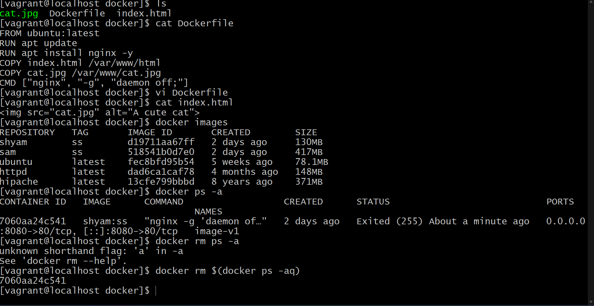

* Using Docker rm $(docker ps -aq) removing exist container from my director
* Using Docker rmi $(docker images) to clear

Now we can see all has removed now will start from scratch to create

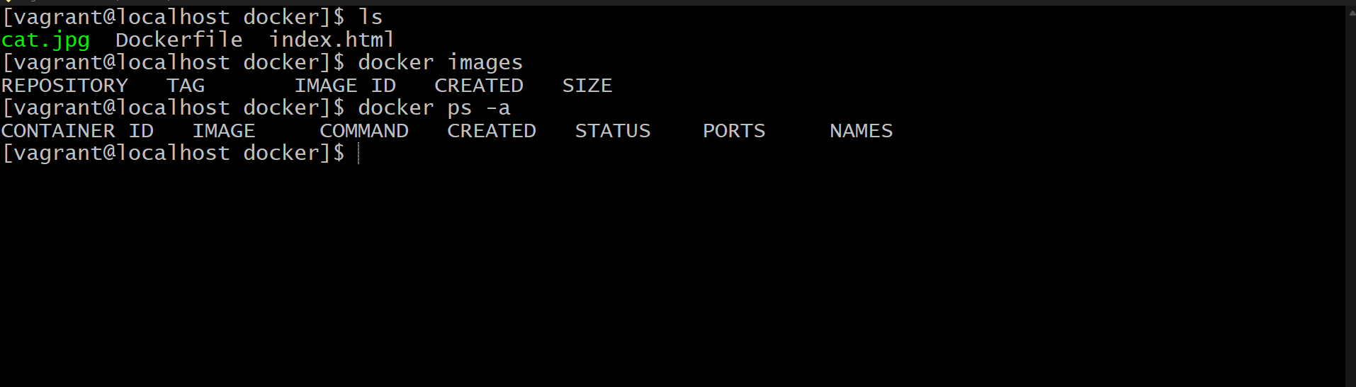

* By using the docker build . we created the docker image
* 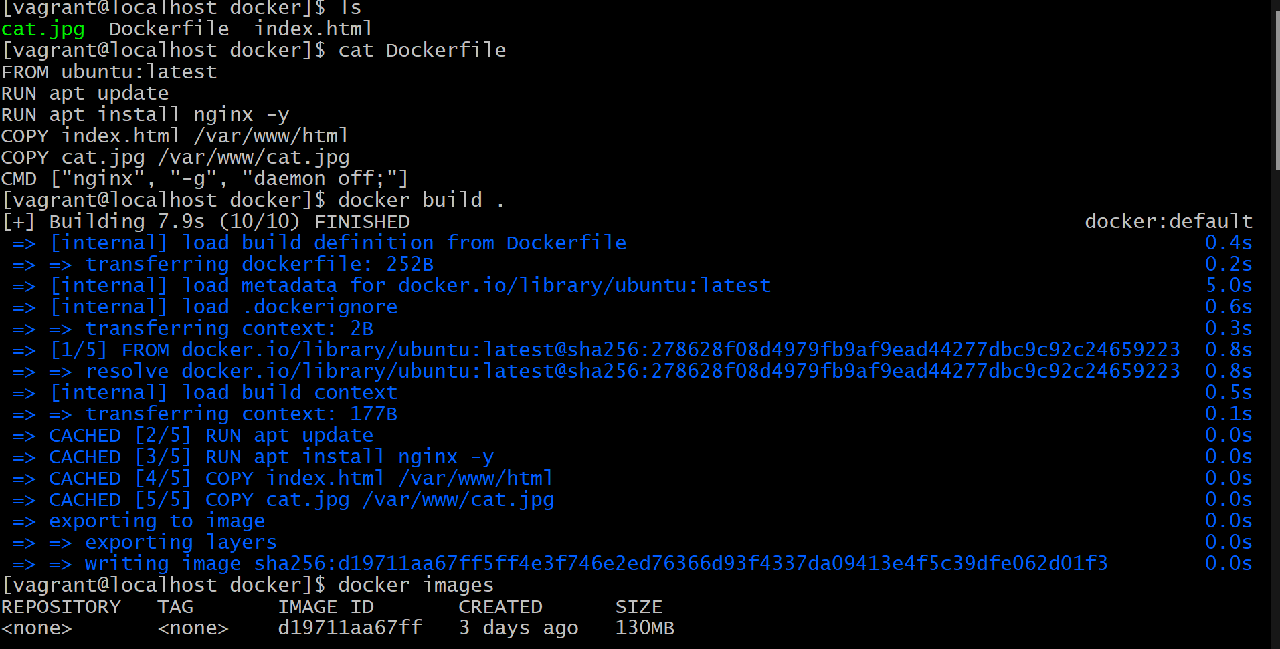

Once its created we can see that Repo and tag name will be blank in that time if wee need to name the function we need to give a commend like

Docker tag <Image ID > repo name tag name

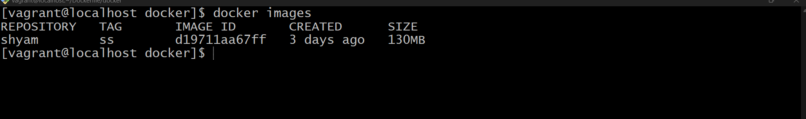

* Once we created we started to run the image by using the below commend
* Docker run -d -it –name app_v1 -p 8080:80 shyam:ss
* -d: Run in detached mode (background).
* -it: Interactive terminal mode (useful for running a shell in the container).
* --name app_v1: Name the container as app_v1.
* -p 8080:80: Map port 8080 on your local machine to port 80 inside the container

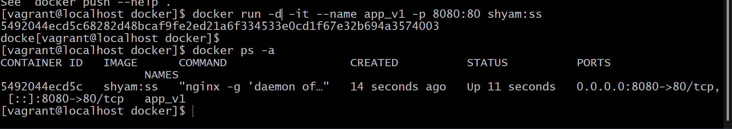

Result in browse : - success

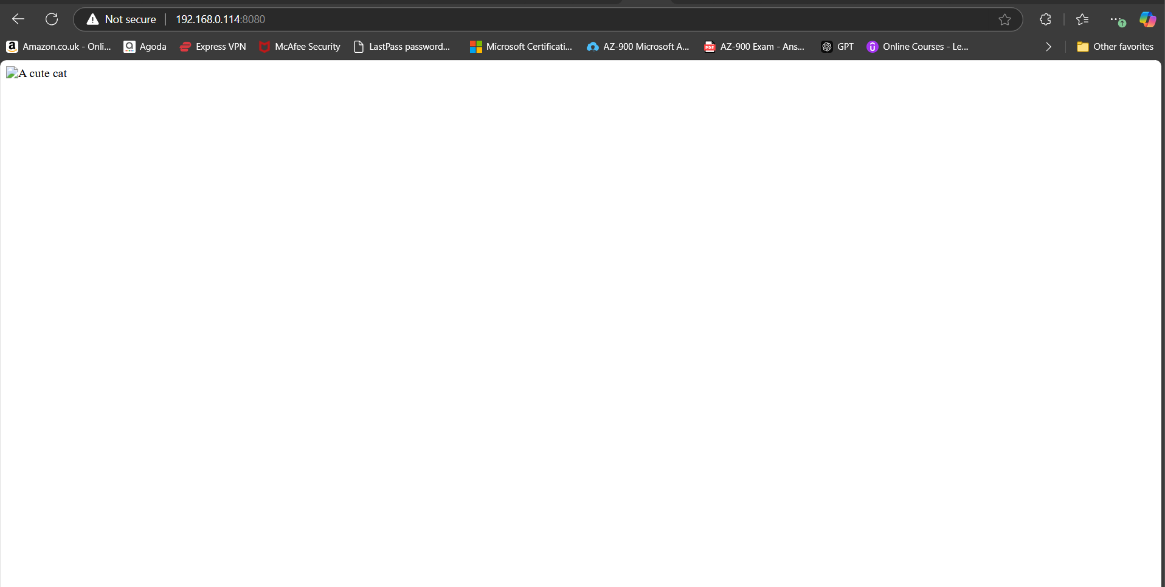

Once we down the container the browser status will comes like

